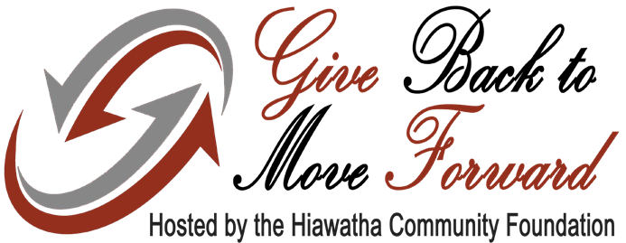
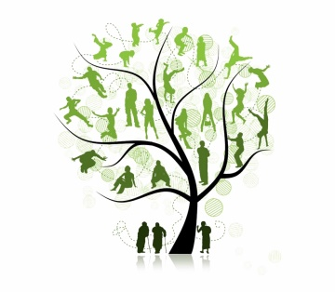
Brown County
Genealogical Society
116 S. 7th St. – Hiawatha, KS 66434
www.brcountyksgs.org ~ brcogenealogy@yahoo.com

Preserving the past
for future generations…
May 6, 2021

Dear Member,

With your help, we could secure additional matching funds during the Give Back to Move Forward Match Event hosted by the Hiawatha Community Foundation, May 29 - 30, 2021!

Give Back to Move Forward holds incredible opportunity for The Brown County Genealogical Society when the Hiawatha Community Foundation will provide a 50% match on gifts to our fund.

Here’s how it works:

Make a donation.
When and Where:
May 29 - Fisher Community Center from 9 am - 5 pm May 30 - Hiawatha Country Club from 12 pm - 6 pm
Online giving at GiveBackToMoveForward.com from 12 am on May 29 - 11:59 pm on May 30

How:
  - Online gifts can be made with a credit card between May 29 - May 30 by visiting www.GiveBackToMoveForward.com
  - Write ONLY one check made payable to HCF for entire gift. Complete the donation form to indicate amounts you would like to give to participating organizations. The form can be downloaded from Give- BackToMoveForward.com. A form is also included with this letter.

Bring your donation and giving form to one of the events listed above.

You can mail your check to P.O. Box 173, Hiawatha, KS 66434. It must be postmarked by May 29, 2021. Please be sure to include donation form.

- Individual contributions to charitable funds ranging from $100 to $1,000 per organization will receive a 50% match until the fund has reached the $1,500 match maximum, or the $35,000 in matching funds has been depleted. If a donor gives a $5,000 gift split evenly between five organizations, then based on such contri- butions, each group would be eligible to receive a 50% match of $500.

Give Back to Move Forward is an opportunity to more quickly grow our funding for charitable and philanthropic causes undertaken by us, so that we can enrich our programs for even greater impact in our community for years to come.

Sincerely,
Charles Carr – President Ray Thieme – Vice-President
Marla Hathhorn – Secretary Gail Coker-Carr – Treasurer

P.S. This is a unique opportunity to multiply the difference we make, and it’s truly a missed opportunity if we don’t take full advantage. Your gift is vital for helping us maximize this match of funds.

The Hiawatha Community Foundation is an affiliate of the Greater Manhattan Community Foundation.
The Greater Manhattan Community Foundation is a non-profit 501(c) (3) organization — EIN #48-1215574, incorporated in the State of Kansas.

